For those who have seen John Hutchinson's reply to this please read http://users.chariot.net.au/~aleck/REBUTTALtoJHCCg27.htm
Send your queries to me.

A Critique of John Hutchinson's attack against Christadelphians
entitled

"What they said would happen"


Contents
Preface

Preliminary points

"Cover-up! Omit! Reprint!"

"Christendom Astray" -- Chapter 16 deleted?

Restored Israel enriched - commerce with India?

Chronological expectations

Gods once men-like animals?

Christianity--a 'Now' religion

The Resurrection

Russia to control European nations?

Is this the 'Hope of Israel'?

Animal sacrifices

Other issues

Conclusion

Acknowledgements

PS: Those familiar with WTSWH will notice that the words in green are from that source.

On the Net at

http://users.chariot.net.au/~aleck/Critique_of_JH_g16.htm

Preface
This critique was written to answer many of the comments made in the pamphlet, What They Said Would Happen (WTSWH) pictured above. It is not our intention to answer here all the points John Hutchinson raises, as many of them have already been answered fully in debates, books, magazines and pamphlets ever since Christadelphians have debated and published books. Hutchinson implies that these very points are new and have never been answered. But the proper definition of the gospel has been documented from clear Bible teaching in the very books that Hutchinson attempts to discredit, and in subsequent publications by other authors.
In some cases John Hutchinson appears to make a point, but it is in most cases not a new point or is a deliberate misrepresentation. Either the point has been answered before and often in the Christadelphian books in which he says it is omitted--and this will be demonstrated in what follows. Or it is as, we say, a deliberate misrepresentation. This is either demonstrated in what follows or the reader is referred to other Christadelphian books, since to try to show it here would result in reinventing the wheel and a publication so large it would be the size of existing Christadelphian books on first principles.
John Hutchinson's point that date setting should not have occurred is correct, but his misuse of Scripture and his conclusion is not valid, as we will demonstrate further on in our critique. Again, it is not a new point as the reader will see but only an attempt to get the reader to swallow his brand of evangelical Christianity which is one of the other gospels that the Apostle Paul warned his readers against.
"But though we, or an angel from heaven, preach any other gospel unto you than that which we have preached unto you, let him be accursed.
As we said before, so say I now again, If any man preach any other gospel unto you than that ye have received, let him be accursed" (Gal. 1:8, 9).
So the real issue is: does the Bible teach the same first principles of the gospel as what Christadelphians teach? The person who comes to the Bible with no preconceived ideas will find that we do. So in what follows we "earnestly contend for the faith which was once delivered unto the saints" (Jude v. 3).

Aleck W. Crawford
February 8, 2015
contents

Preliminary points contents
We start off our preliminary comments by saying it must be understood that all men make mistakes, so we will not be defending behaviour that is unscriptural.
Nor will we defend any doctrine that is unscriptural since Christadelphians are seekers of the Truth which God has revealed in His word, not promoters of pagan mythology or tradition, as are most of the churches, including their evangelical wings. It is observable that John Thomas was still learning some aspects of what he wrote about the Bible in his Confession and Abjuration and Declaration written in 1847 and in Elpis Israel in 1849. We generally agree with his later writings where those clarify what he had said earlier.
Christadelphians (which means Brethren in Christ) are not a perfect community. There never was one. Look carefully at the Old Testament and you won't find perfection. Even Solomon the wisest man failed. In the New Testament the Gospels, Epistles, and the Revelation are documents that show anything but a perfect community. Speaking of the Adamic creation, the only perfect person was the Lord Jesus Christ.
Christadelphians do not claim inspiration and are not prophets. Therefore the words recorded in Deut. 18:20, "If what a prophet proclaims in the name of the LORD..." do not apply to us. We don't proclaim anything "in the name of the LORD".
Christadelphians do not have a headquarters nor a hierarchy dictating what is to be believed. Because of this, it should be obvious to any fair-minded observer that we cannot prevent outspoken or radical members from making statements about dates or chronology. What Christadelphians agree to is their Statement of The Faith that contains, among other fundamental Bible teaching, many Biblical first principles that can only be described as prophecy. Outside of that framework some variation of exposition occurs in our community.
Even after they had been personally instructed by Jesus for three and a half years, and especially for the previous 40 days (by the risen and glorified Lord) of the things concerning "the Kingdom of God", all 11 Apostles of the Lord got their prophetical date or "times" badly wrong when they said as recorded in Acts 1:6,7 -
"When they therefore were come together, they asked of him (Christ), saying, Lord, wilt thou at this time restore again the kingdom to Israel? And he said unto them, It is not for you to know the times or the seasons, which the Father hath put in his own power."
Notice Christ did not say, "you got it all wrong. You are false prophets and no one can any longer believe anything you say". Christ did not say, "your other beliefs and hopes are wrong". The Lord's reply indicates quite a lot. The Lord Jesus Christ is to be king. The kingdom is going to be on earth just like the previous kingdom had been. It is to be a "restored" kingdom. And it would involve the hope of "Israel". Likewise, the interpretation of prophecy by much lesser men has sometimes been wrong on detail but the vast majority of Christadelphian understanding has proved correct with the passage of time. We will say more on that later in this critique. Chronological expectations
John Hutchinson criticises Christadelphians but he puts forward no ideas (in WTSWH at least) to explain Bible prophecy. This is a serious omission as he claims the Holy Spirit has come into his life, so therefore he should be able to correctly explain prophecy.

Answers to Specific Allegations
As our graphic of John Hutchinson's pamphlet implies, in this critique we will to peel back his cover and investigate the contents.

"Cover-up! Omit! Reprint!" contents
The implication in John Hutchinson's sensational subtitle--"Cover-up! Omit! Reprint!"--on what serves as a contents page of WTSWH is that Christadelphians have deliberately "covered-up" failed predictions, "omitted" them without comment, and "reprinted" numerous books so as to cover up failed predictions. On page 2 of WTSWH he writes 'Cover up, omit and reprint. -- This seems to be the ploy of Christadelphians ... as the ... example illustrates. They have reprinted numerous books and deleted the failed forecasts--sometimes with an apology that the author's announcements proved "premature"'. This admission by Hutchinson that the publishers did say the announcements were "premature" proves that his use of the emotive words "cover-up" and "ploy" are false. Either they covered-up in which case he has a point or they admitted their mistakes in which case he doesn't. He can't have it both ways. In fact anyone who has a look at most of the editions of Elpis Israel will soon see that this claim of Hutchinson's is far from the facts.
On "cover-up", for example, the fourteenth edition of Elpis Israel on the title page says it is "Revised". That one word is enough to disprove the "cover-up" allegation. If a publisher wanted to "cover up" they would not put "revised" on it otherwise that would give the alleged "ploy" away. And where is the publisher who details every single thing that is revised? But there is much more to this disclosure than simply saying 'revised'. There are 27 pages of "Publisher's Preface", "Biographical Notes", "Author's Prefaces" from the first four editions, and "Publisher's Notes"!
In the Publisher's Preface we have the following declaration: "The third part of the book deals with prophecy in relation to world affairs. Here understanding was influenced by an expectation of the Lord's early advent, which proved premature, and much that has now to be treated with reserve derived from this outlook. Whilst some things looked for came to pass others did not". Those three sentences are the opposite of a cover-up.
In the Biographical Notes it is revealed that John Thomas published in 1847 "A Confession and Abjuration of past erroneous belief and contentions and was re-immersed". If John Thomas was the type of person who wanted to "cover up" or omit the fact that his further study of the Scriptures demonstrated that some of his previous beliefs were wrong, he would never have written this major admission nor published his Confession and Abjuration and Declaration. If subsequent publishers wanted to "cover-up" this confession they would not have mentioned this in Elpis Israel nor republished it in books such as Dr Thomas: His Life and Work.
In the Author's Preface to the first edition on page XIX of the Fourteenth Edition, John Thomas upon revising his first draft "found some things omitted, others touched too lightly, and other parts too diffuse so that upon the whole, he condemned it as unsuitable, and imposed upon himself the task of writing it over again". This action is the characteristic way in which he behaved and is after the manner of the previous point. If John Thomas was wrong he would admit it as he did in his rebaptism, and his comments in the next point. So too, if John Thomas were alive today he would condemn his second writing of section three as "unsuitable" and impose upon himself the task of writing it over again.
In the Author's Preface to the fourth edition in 1866 he has this to say: "For the first time since correcting the proof of the first edition in 1849, he has read the work again". Then he speaks of the changes made. "He has made about half-a-dozen in the first part; and less than that in the second. In the third part he found it necessary to make the most". A "cover-up"? Hardly! In fact because he changed his view on the state of the resurrected he makes this clear in over half a page in the preface. If he had wanted to cover up he would most certainly not have stated these things. So what the evidence presents is not deception but the opposite--the humility of a man who admits his errors in print. This is John Thomas' strength, not a weakness.
One of the reasons the Publisher's Notes were included was specifically to "'cut off occasion' from some who would not be slow to accuse the publisher of 'tampering' with the work of the deceased". Part of those two pages lists the page numbers where changes were made in regard to "some erroneous anticipations that the efflux of time has manifested concerning the end of the age".
Also in the vast majority of cases where the publisher has made changes there are footnotes to that effect. We have looked at a lot of books in our lifetime but we have never seen a book where the publisher details the changes made in it so carefully as does the publisher of Elpis Israel.

On the word "omit" we will demonstrate, in what follows, that several publishers have in fact not omitted what John Hutchinson said Christadelphians have omitted. His research was either insufficient or he omitted to mention these facts. But before we present the evidence against his claim that we "omit" ostensibly to deceive, perhaps the reader would like to know that Hutchinson omitted almost a whole sentence (in blue or bold italics font) in the quote (reproduced below) he makes from Elpis Israel on page 2 of WTSWH!
"The policy they originate is to involve the whole habitable in war the more immediate effect of which will be, that the 'king of the north shall enter the countries, and shall overflow and pass over'. To 'enter into the countries' implies invasion, but to 'overflow and pass over' indicates conquest. The result of the conquest will be that 'many countries shall be overthrown'. The war will have made terrible havoc with the Horn kingdoms and the Austro-Papal Empire; the former will have lost their independence, and the latter will have been destroyed unto the end." [Elpis Israel pp.375-6 (1849)]
So he is not perfect either despite his attacks on others who are not perfect and despite his claim to have the spirit.
The following is a partial list of editions or publishers who have not done as Hutchinson has claimed:-

"Sentences underlined are omitted from later editions of Elpis Israel without explanation"
and the documented evidence.
1904 edition (graphic follows) sentence not omitted!
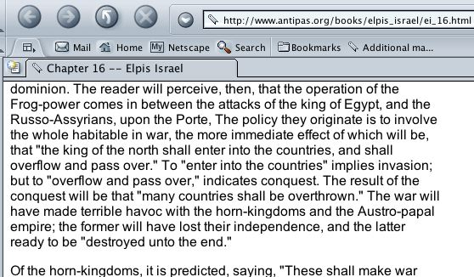

As we said this is the 1904 edition of Elpis Israel and as you can see the sentence is not omitted.
Second edition (1851) sentence not omitted!
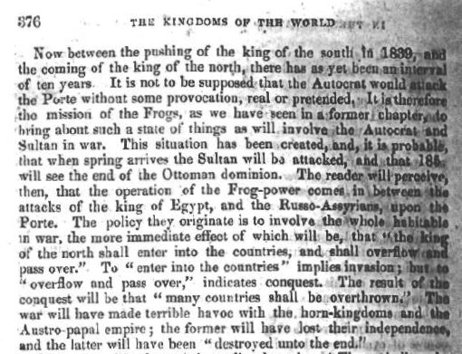
Fourth edition (1866) not omitted!
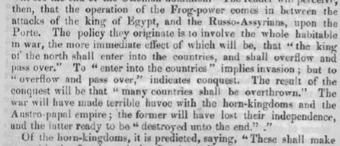
Third edition (1859), etc. Obviously if the 1904 edition did not have the sentences removed then the second, third, fourth and every other edition up and including 1904 edition, if done by the same publisher, did not have the sentences omitted.
Logos republished 4th edition 2000 sentence not omitted!
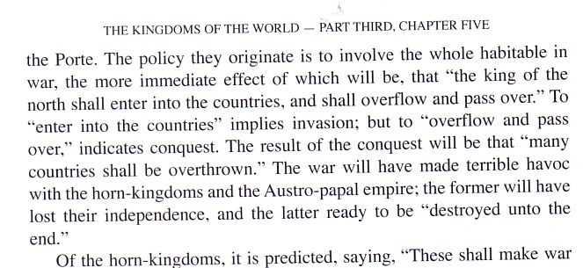

On "reprint" it is patently obvious from hard evidence in the third and fourth prefaces that John Thomas was pressured into issuing these editions, not to "cover-up" or "omit" but because they had been out of print in the first instance for "the past three years" or--in the case of the fourth edition--"for a considerable time there has been no copies for sale". When he was pressured to produce the fourth edition he wrote that "the author has reluctantly responded" So Hutchinson's innuendo that there was reprinting going on to "cover-up" is just not sustainable to any fair-minded person.
It is incontrovertible that the so called second and third editions were in fact not what we today would call editions but essentially reset reprints apart from the prefaces. So John Thomas had 16 years to cover-up and omit, but the facts are that he did not. The facts are all the other way.

"Christendom Astray" -- Chapter 16 deleted? contents
Under the general heading of "cover-up" etc Hutchinson quotes from one publisher (CMPA) of this book in its 1958 edition.
'In the Preface to the 1958 edition of 'Christendom Astray' we note the following:
The whole of Chapter 16, on the "Evidence that the End is Near", has been deleted.
As it was desired that the book should be left as the work of Robert Roberts, the only alternative was to delete the whole chapter, while referring readers to more recent Christadelphian publications for information on the evidence that the coming of Christ is near.'
Is this evidence of a "cover-up" as Hutchinson implies or is it not rather the opposite? If you are attempting to cover up something you don't explain in the very front of the book in the preface that you are deleting something: you just delete it and hope that nobody who cares notices!
But the fact of the matter is that in 1984 another publisher in Adelaide, which is very close to where Hutchinson lives, did not follow suit. I have for two decades had on my bookshelf the Logos edition of Christendom Astray that retains Lecture (i.e. chapter) 16. In the Foreword on page 12 the publishers say, "his anticipation of the return of Christ at that time, and the establishment of the Kingdom by 1906, was incorrect". In Lecture 16 there is a reference back to the Foreword and a footnote or two of the same nature.
The closing paragraph is now presented so the reader can determine how valid Hutchinson's innuendo of a "cover-up, omit, reprint" is.
'Robert Roberts made a mistake in setting a date for the establishment of the Kingdom of God on earth, because the Bible clearly states: "of that day and that hour knoweth no man, no, not the angels which are in heaven, neither the Son, but the Father" (Mark 13:32). There are time periods set down in the Bible, but they do not reveal that date, and the fact that Robert Roberts made a mistake in regard to them only serves to underline the importance for every reader of Christendom Astray to turn to the Bible himself for confirmation of the matters set before him. Let him do this and he will be led into all truth, and rejoice in the knowledge of God's plan of salvation, and His future purpose to send back Jesus Christ to this earth, that he might establish therein the universal Kingdom over which he will reign (Acts 1:11; Daniel 2:44; Zechariah 14:9). There is a "day appointed" for this glorious and wonderful event (Acts 17:31), and the signs of the times show that it is near at hand, for "at the set time," "when the Lord shall build up Zion, He shall appear in His glory" (Psalm 102:13, 16).'
Robert Roberts himself states in his preface to the 1884 edition (on page 8 of the Logos edition mentioned above) that there had been "a failure not in the prophetic word, but in human estimate of probability." On page 9 he says "Of the exact date of the Lord's appearing we have no information."
All 5 publishers listed on the online Christadelphian booklist on the Internet do not omit Lecture 16.
http://users.aol.com/bible4/chrastoc.htm
http://www.antipas.org/books/chris_astray/ca_toc.html
http://thechristadelphians.org/htm/books/astray/astray_mainframe.htm
http://www.biblelight.org/ca/caind.htm
http://www.angelfire.com/bc2/Bereans/Cornerstones/Pioneers/Ca/chrastoc.html

Let's ask a few questions. Did The Christadelphian cover up that they were deleting a chapter? No! They said so in the preface. Did Logos Publications (and the 5 online publishers above) omit Lecture 16? No! Did they cover up his error? No! Did Robert Roberts omit his Lecture 16 in 1884? No! Did he cover up his error? No! Did either book publisher "reprint" to "cover-up" anything? We'll let the reader determine the obvious answer.
So who is doing the omitting? Did Hutchinson offer one word on why the other 17 lectures or chapters were unbiblical? Certainly not in the WTSWH pamphlet.

"Predictions of Ireland, India and Britain failed. contents
Thomas said that a restored Israel would become rich through commerce with India [Elpis Israel (1949) p. 441]. When has India made a restored Israel rich? ..."
The above title and two sentences are a quote from WTSWH page 2. On Ireland, one only has to do a "find" within his WTSWH document and you will soon discover there is no other mention of Ireland in his document. Perhaps Hutchinson omitted something and forgot to cover-up his omission by changing his title? But what the reader should notice is that Hutchinson implies he is quoting from Elpis Israel but there are no quotation marks. So in actual fact Hutchinson is not quoting John Thomas; rather he is giving a summary of what he (Hutchinson) thinks John Thomas said. But his summary is completely wrong. We will quote Elpis Israel so the reader can see the point.
'There is, then, a partial and primary restoration of Jews before the manifestation, which is to serve as the nucleus, or basis, of future operations in the restoration of the rest of the tribes after he has appeared in the kingdom. The pre-adventual colonization of Palestine will be on purely political principles; and the Jewish colonists will return in unbelief of the Messiahship of Jesus, and of the truth as it is in him. They will emigrate thither as agriculturists and traders, in the hope of ultimately establishing their commonwealth, but more immediately of getting rich in silver and gold by commerce with India, and in cattle and goods by their industry at home under the efficient protection of the British power. And this their expectation will not be deceived; for, before Gogue invades their country, it is described by the prophet, as "a land of unwalled villages, whose inhabitants are at rest, and dwell safely, all of them dwelling without walls, and having neither bars nor gates; and possessed of silver and gold, cattle and goods, dwelling in the midst of the land" (Ezek. 38:11,12,13).'
Now it does not take much knowledge of English to see from this quote that it was the Jews who had "the hope" and "expectation" of getting rich with "commerce with India" "more immediately". It was not John Thomas making a prediction. John Thomas did however point out that they would achieve their expectation of getting rich before "Gogue invades their country" because the Prophet Ezekiel prophesied that they would possess "silver and gold... cattle and goods" in such large proportions that it would amount to "a great spoil" (Ezek. 38:13) to the invaders. Gogue has not yet invaded the country that established "their commonwealth" (i.e. state) in 1948. The news in 2003 was that Israel was making huge sums of money out of trade with India. Debka.com reported:-
"Indian-Israel trade will more than double to $3b by end of 2003. Bank of India has applied for permit to open a branch in Israel to handle diverse bilateral transactions including military and electronic surveillance equipment and missiles." 1/12/2003
India and Israel have a lot in common now, both having a common concern. Whether their silver and gold will come from India is not really important. But it seemed so to Jews in 1849.
Chronological expectations contents
One of the main thrusts of John Hutchinson's WTSWH is in the area of premature expectations as far as the return of Christ and the start of the millennium were concerned. In addition to the preliminary points on this subject made at the start of this critique, there are several points we wish to put before the reader to balance this criticism of John Thomas.
This same zeal was exhibited beforehand by many of the faithful, as we will see from several Biblical examples. We have already mentioned the most obvious example--that occurs in Acts 1:6-7 (in preliminary points). By looking at the Scriptures we can see that it was a general belief among the faithful that Christ would return in the first century.
The Apostle Paul had to warn the ecclesia in Thessalonica that Christ would not return when they expected it, and not to be deceived by anyone who said or wrote something to that effect:
"Now, brethren, concerning the coming of our Lord Jesus Christ, and our gathering together to Him, we ask you, not to be soon shaken in mind, or troubled, either by spirit, or by word, or by letter, as if from us, as though the day of Christ had come. Let no one deceive you by any means; for that day will not come unless the falling away comes first, and the man of sin is revealed, the son of perdition, who opposes and exalts himself above all that is called God, or that is worshiped, so that he sits as God in the temple of God, showing himself that he is God. Do you not remember that when I was still with you I told you these things? And now you know what is restraining, that he may be revealed in his own time. For the mystery of lawlessness is already at work; only he (mg.) who now restrains will do so until he (mg.) is taken out of the way. And then the lawless one will be revealed, whom the Lord will consume with the breath of his mouth and destroy with the brightness of his coming. The coming of the lawless one is according to the working of Satan, with all power, signs, and lying wonders, and with all unrighteous deception among those who perish, because they did not receive the love of the truth, that they might be saved. And for this reason God will send them strong delusion, that they should believe the lie, that they all may be condemned who did not believe the truth but had pleasure in unrighteousness" (2 Thess. 2:1-12 NKJV).

So Paul is clearly saying in the above quotation that Christ will not come until the falling away or the apostasy comes first. This apostasy would believe "the lie" which is a specific reference to what the serpent said to Eve that she would not die. So Christ was not to come in their lifetime, and not until the man of sin was revealed. So we can now see the expectation of the Thessalonians that the return of Christ would be in the first century was wrong by over 1900 years! But they did not know that because, as we shall see from the telescopic structure of the Apocalypse chart below, God's revelation was given in such a way as to encourage every generation to faith and an expectancy or hope so that they might not "sleep" but "watch and be sober" (1 Thess. 5:2). Notice again that Paul did not say all their doctrines were wrong because they had their date of the return of Christ wrong or that they were false prophets.
The following is a partial list of verses that imply the first century believers thought Christ would return in their lifetime.
1Cor. 1:7 So that ye come behind in no gift; waiting for the coming of our Lord Jesus Christ:
1Thess. 2:19 For what is our hope, or joy, or crown of rejoicing? Are not even ye in the presence of our Lord Jesus Christ at his coming?
1Thess. 3:13 To the end he may stablish your hearts unblameable in holiness before God, even our Father, at the coming of our Lord Jesus Christ with all his saints.
1Thess. 4:15 For this we say unto you by the word of the Lord, that we which are alive and remain unto the coming of the Lord shall not prevent them which are asleep.
1Thess. 5:23 And the very God of peace sanctify you wholly; and I pray God your whole spirit and soul and body be preserved blameless unto the coming of our Lord Jesus Christ.
2Thess 2:1 Now we beseech you, brethren, by the coming of our Lord Jesus Christ, and by our gathering together unto him,
2Thess 2:8 And then shall that Wicked be revealed, whom the Lord shall consume with the spirit of his mouth, and shall destroy with the brightness of his coming:
James 5:7 Be patient therefore, brethren, unto the coming of the Lord. Behold, the husbandman waiteth for the precious fruit of the earth, and hath long patience for it, until he receive the early and latter rain.
James 5:8 Be ye also patient; stablish your hearts: for the coming of the Lord draweth nigh.
1John 2:28 And now, little children, abide in him; that, when he shall appear, we may have confidence, and not be ashamed before him at his coming.
Are we to condemn James the Lord's brother as a false prophet? We ask the same question of John Hutchinson about his apostolic namesake? Finally, was the great Apostle Paul a false prophet? Of course not! We just have to understand how God gave his revelation.

Telescope structure of Revelation
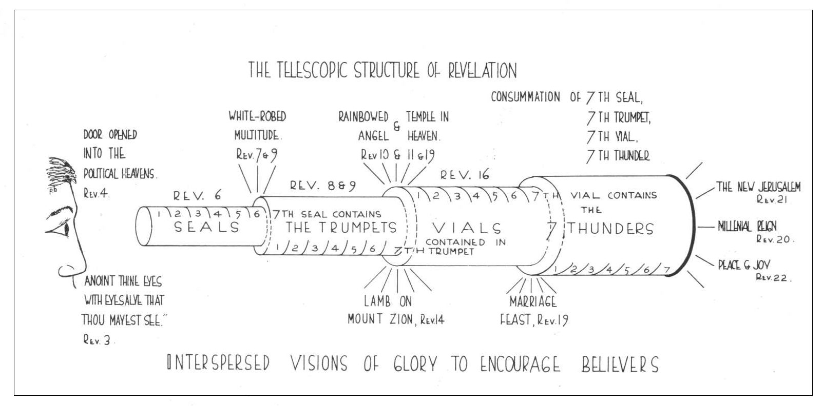
What this chart shows is the structure of Christ's last message to his followers. We can't go into detail here but what it shows is that the one looking through the telescope can see visions of glory at the end of various symbols used (including the millennial reign of Christ, the peace and joy of the kingdom etc.) but cannot see how long the telescope is. So he could see the relevance of the symbol(s) for his times but could not tell how long it would be until the return of Christ. Only those who are in the last days can see how long the various seals, trumpets, and first five vials took to be fulfilled. These interspersed visions of glory were to encourage the faith of the believer. For example, those living today under the sixth vial have as their vision of glory the marriage feast of the lamb.
John Thomas admits his times may be speculation
John Thomas admits that his times may be speculation. For example he says in his pamphlet The book unsealed published in 1869, "God is never in a hurry. He has plenty of time at His disposal. He is not bound to do things according to your speculation or mine as to how long He ought to take."

No claim to divine guidance or Holy Spirit
Unlike the Catholics which claim the Pope is infallible in his pronouncements if he speaks ex-cathedra or Mormons who claim God speaks through their spirit-guided president or Evangelicals who claim to be guided by the Holy Spirit or Pentecostals who claim to have one or more of the Holy Spirit Gifts or Jehovah's Witnesses who claim God speaks through the organisation, Christadelphians do not claim to have the spirit, nor do they claim God speaks through them. John Thomas never claimed to be a prophet and no balanced Christadelphian would claim this for him. This is a fundamental difference--between the mother church and her Protestant daughters on one hand and the faithful remnant on the other--so John Hutchinson's claim that John Thomas was a false prophet is just a straw man that he has erected and then proceeds to knock down. In logic it is known as "a red herring".

Errors in prophetical times
It is simply incorrect to say Christadelphians "cover up" or "omit" their errors in prophetical dates. For example, in the following letter to the editor of The Christadelphian, Harry Tennant warns readers not to speculate about the future. It carried the title PROPHECIES THAT WENT WRONG.
'... My point in writing to you is to urge speaking brethren to be more circumspect in the use of Scripture, particularly prophetic Scripture, especially when preaching the gospel to others...
There are future events about which we can be certain and there are events which are not yet clear. There are prophecies we can interpret from the housetops and there are speculations which are best kept for private thought or for Bible class discussion. Addresses for the preaching of the truth of salvation are no place for flights of fancy concerning the future. How is the interested friend to trust our setting forth of first principles if our dogmatism on unproved theories collapses with the passing of time? Let us keep sound doctrine and personal peeps into the future quite separate.
Saints throughout the ages have searched what or what manner of time the word of the prophets has signified. Sometimes they have been able to discern clearly and sometimes they have been forced to wait for the event to speak for itself. Alert minds, made lively by thorough acquaintance with the word of God, will look ahead with the Bible in hand. Brethren will exchange ideas with brethren and thereby keep alight the fires of hope during the long night of waiting. This is a good exercise providing it observes two principles; (i) nothing should be said which conflicts with the well-established doctrines of salvation; (ii) all that is said should do honour to the word of God in all its parts...'

So we agree that these predictions about the date of the return of Christ and the start of the Millennium should not have been made. As we said in the Preface, John Hutchinson's point that date setting should not have occurred is correct, but his misuse of Scripture and his conclusion is not valid, as we have demonstrated in our critique.

Getting the right balance
The following paragraphs, taken from an article on prophecies about the Messiah, help to give readers the right balance on prophetical times.
'In Habakkuk 2 we are told to be patient because the vision or prediction will speak, and although it is for a time appointed by God we are to "wait for it", and it will surely be performed at the "appointed time".
It is evident from what has been already said that the prophets could not have had a perfect understanding of all the prophecies they were inspired to utter; there must have been many uncertainties as regards the time and the manner of their fulfilment, though none about the final outcome. So Peter says that, concerning the salvation of God's people, "the prophets sought and searched diligently, who prophesied of the grace that should come upon you: searching what time or what manner of time the Spirit of Christ which was in them did point unto, when it testified beforehand the sufferings of Christ and the glories that should follow them", for they realised that they were not God's ministers just for their own sake, nor just for the sake of their contemporaries, but for future generations who would see their words come to pass (1 Pet. 1:10–12). The prophets, then, must have been aware that their words possessed a scope and a relevance which went far beyond any obvious application to their own day.'
Gods once men-like animals? contents
The following is the title of one of Hutchinson's major points in his second page, which doubles as a contents page

On page 11 of WTSWH Hutchinson has this
"John Thomas postulated a concept of God and creation that seems to have affinities with Platonism and Mormonism.

. . . . 'gods once animal like men'
Thomas denied the scriptural teaching of a direct creation by God and substituted an idea of creation by 'gods'. 'These gods', he suggested 'were once animal like men of other spheres who aspired to Godhood'... (See Elpis Israel p. 187)"

reply
Note that the title on page 2 and the supposed reproduction of it on page 11 are different. Also note well the quote as John Hutchinson has it (in bold above) does not appear in Elpis Israel.
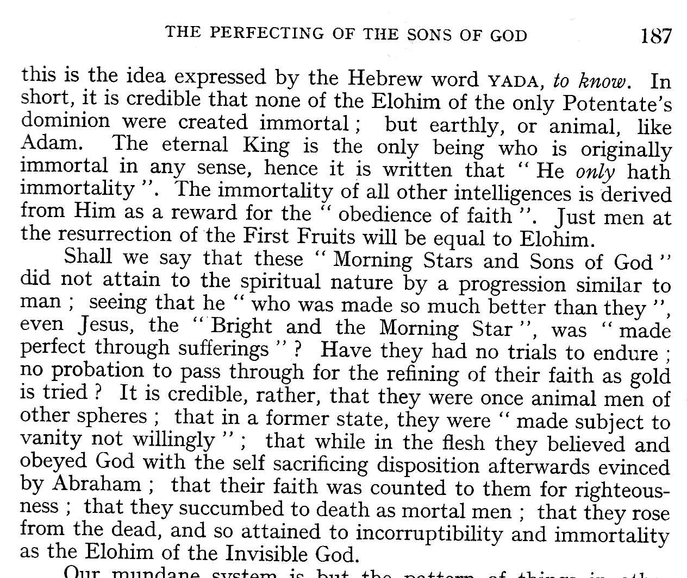
We have included a graphic of the page so readers can determine how far Hutchinson's quote is from what John Thomas actually said.
So if Hutchinson can't even quote accurately (also putting in his own conclusions) and falsely representing them as being quoted from Elpis Israel, any fair-minded reader will be able to see clearly that Hutchinson is pushing his own wheelbarrow with the express purpose to discredit. Once the words inserted by Hutchinson ("who aspired to Godhood") are removed then it becomes obvious to anyone who knows Mormonism's theories that what John Thomas said has no affinity with these theories. And if the reader knows how hard John Thomas fought again the theories of Plato then Hutchinson's allegation becomes a bad joke.

Animal Men
If we would understand what John Thomas means in Elpis Israel when he wrote of The Elohim being "once animal men of other spheres" the quote below written in The Apostacy Unveiled in 1838, 11 years before will answer the matter. He is expressing his belief that the angels were at one stage unenlightened but that they attained to "immortality as the Elohim of the Invisible God".
Of course anyone acquainted with some Lexicon or Concordance such as Strong's could arrive at his meaning also since the word "natural" in 1 Cor. 2:14 ("the natural man") is the Greek word #5591 psuchikos. Strong's says this means "sensitive, i.e. animate (in distinction on the one hand from 4152, which is the higher or renovated nature, and on the other hand from 5446, which is the lower or bestial nature."
Bullinger has this to say about psuchikos: "breathing, animal, possessing animal life, swayed by the animal mind and affections..." Vines Expository Dictionary says it describes the man in Adam...(set in contrast to pneumatikos, spiritual). In James 3:15 for "sensual" the RV margin has "natural" or "animal".
Jude defines them as "sensual (same word), having not the spirit" (v. 19).
Of course anyone familiar with Psalm 49 would not need a concordance or other help to determine what God says about unenlightened man:-
Psa. 49:12 "Nevertheless man being in honour abideth not: he is like the beasts that perish.
Psa. 49:20 Man that is in honour, and understandeth not, is like the beasts that perish.
So where we read "animal men" in Elpis Israel we know he meant "natural" or unenlightened. He was using Biblical terminology, certainly not the ideas of the Mormons as Hutchinson falsely alleges. Perhaps John Thomas could have defined this term more clearly for readers of today but most of his readers in 1850 would have known what he meant. In any event how was he to know people would be reading his book 150 years later?
We have to remember that Elpis Israel was written to restate that the hope of the faithful was indeed the Hope of Israel--the restored kingdom of God on earth--in contrast to the common apostate, pagan idea of the inherent immortality of the soul and heaven going.
As a matter of fact the Diaglott has the following for 1 Cor. 2:14: -
"Now, an Animal Man does not receive the things of the Spirit of God, for they are foolishness unto him; and he is not able to understand..."
We conclude that most of John Thomas' readers would be familiar with this terminology as it was common at the time.
Were the angels (i.e. the Elohim) involved in creation?
The main thrust in Hutchinson's argument is that the creation was done directly by God, and the Elohim were not involved.
"Thomas denied the scriptural teaching of a direct creation by God and substituted an idea of creation by 'gods'. ..."
That God--or to use His revealed covenant name, Yahweh--was the prime mover of the Genesis creation is not in disagreement. The Bible says so, Christadelphians say so and John Thomas said so. But to say that the angels or Elohim or (the imprecise word) 'gods' were not involved in creation is something not supported by Scripture. It is pretty obvious from the Genesis record and by comparing it with other Scriptures that the beings who were involved in the detailed work of creating the earth and its inhabitants were not God Himself. That may sound like a contradiction but not if you understand how God's messengers do His will, as we shall presently see. Not only have we proven that God is ONE above but we now will demonstrate that the Bible clearly says:-
"No man hath seen God at any time..." (John 1:18)
"Not that any man hath seen the Father..." (John 6:46)
"Who only hath immortality, dwelling in the light which no man can approach unto; whom no man hath seen, nor can see..." (1Tim 6:16).
Now it is without a doubt obvious that Adam and Eve saw the being that brought the woman, who he had made out of Adam's rib, to Adam (Gen. 2:22). It is also evident from a careful reading of chapter 3:22 that these beings termed "us" are the same as the "us" of Genesis 1:26 and that they are Elohim, with the chief one bearing the name Yahweh Elohim. It is also clear that though Adam and Eve tried to hide their sin and themselves "from the presence" (Gen. 3:8) of these Elohim, they could not and so were cursed for their disobedience. The Elohim provided them with "coats of skins", and these Elohim sent Adam out of the Garden of Eden. So it is abundantly clear that man saw these Elohim, so therefore they were not God Himself.
What were these Elohim or as the serpent said, "gods"? We only need to compare Psalm 8:5 "For thou hast made him a little lower that the angels (Heb. Elohim)..." with Hebrews 2:7 to discover that Elohim often refers to God's immortal angels. So what we have in Genesis 1-3 is a description of God's immortal beings, the angels, doing His bidding in creation (cf. Job 38:7).
This type of representative language is common today. If the Post Office parcel deliveryman knocks on your door and you say "who is it?" they will answer "Australia Post" or something similar in other countries. We know it is one of their lesser representatives, certainly not the CEO or President himself! So likewise when God or Yahweh did something in the past on earth he sent his representatives to do the task for the reasons quoted above. For example in Genesis 18:1 it says Yahweh appeared unto (Abraham). In verse 2 it says Abraham saw "three men". It becomes obvious as the chapter goes on that not only were they not men but angels and one of the "men" bore the Divine Name Yahweh and two others were lesser beings and are described in Genesis 19:2 as "two angels". So it was not God Himself, not three men (though they looked like man) and certainly not the trinity for there is no such thing! We are told in the new Testament that the angels are "all ministering spirits, sent forth to minister for them who shall be heirs of salvation".
Notice that Hutchinson makes no attempt to explain these verses of the creation account.

Christianity--a 'Now' religion contents
'Behold, now is the accepted time; behold, now is the day of salvation.' 2 Cor 6:2
'Beloved, now are we children of God.' 1 John 3:2
'. . . being now justified by his blood.' Rom 5:9
'. . . we have now received the atonement.' Rom 5:11
'There is therefore now no condemnation to them that are in Christ Jesus.' Rom 8:1
'. . . but are now the people of God.' 1 Pet 3: 10

'If any man is in Christ Jesus he is a new creation; old things have passed away, Behold, all things have become new.' 2 Cor 5:17

Is that the final word? Like most evangelicals, John Hutchinson quotes verses like those above (WTSWH p. 10) that on the surface appear to support his view that 'once saved always saved' or 'eternal security'--while at the same time completely ignoring many other clear verses (often contextual) which speak of life in Christ as what could be described as a probation.

Hutchinson's out of context quote | What does the context say? | Conclusion
'If any man is in Christ Jesus he is a new creation; old things have passed away, Behold, all things have become new.' 2 Cor 5:17 | "Wherefore we labour, that, whether present or absent, we may be accepted of him.  For we must all appear before the judgment seat of Christ; that every one may receive the things done in his body, according to that he hath done, whether it be good or bad." (2 Cor. 5:9, 10) | If we have salvation now, why is there a need to appear at the judgement seat?
'Behold, now is the accepted time; behold, now is the day of salvation.' 2 Cor 6:2 | "We... beseech you also that ye receive not the grace of God in vain.  And what concord hath Christ with Belial? or what part hath he that believeth with an infidel?  And what agreement hath the temple of God with idols? ...Wherefore come out from among them, and be ye separate, saith the Lord, and touch not the unclean thing; and I will receive you, (2 Cor. 6:1, 15-17) | So it was possible to "receive the grace of God in vain". One of their problems was they thought it was OK to enter the temple where idols were. The divine instruction is "come out from them...and I will receive you" The clear warning was if they didn't he would not receive them.
'Beloved, now are we children of God.' 1 John 3:2 | "Beloved, now are we the sons of God, and it doth not yet appear what we shall be: but we know that, when he shall appear, we shall be like him; for we shall see him as he is. And every man that hath this hope in him purifieth himself, even as he is pure." 1 John 3:2  "And this is the promise that he hath promised us, even eternal life." (1 John 2:25) | When he (Christ) shall appear we shall be like him, not before. It is a hope we have in him, so we need to purify ourself.  So eternal life is a promise, not a present possession.

'. . . being now justified by his blood. '. . . we have now received the atonement.' Rom 5:9, 11 | "By whom also we have access by faith into this grace wherein we stand, and rejoice in hope of the glory of God." (Rom. 5:2)  cf. "For we are saved by hope: but hope that is seen is not hope: for what a man seeth, why doth he yet hope for?  But if we hope for that we see not, then do we with patience wait for it." (Rom. 8:24, 25) | Yes we are justified "now" but we still live in hope of the glory of God. As Paul argues we are "saved by hope", not something which we already have. The NIV has "who hopes for what he already has?" Nobody of course!
'There is therefore now no condemnation to them that are in Christ Jesus.' Rom 8:1 | "For if ye live after the flesh, ye shall die: but if ye through the Spirit do mortify the deeds of the body, ye shall live." (Romans 8:13) | If we "mortify the deeds of the body" we "shall live". If we don't we shall die eternally.
'. . . but are now the people of God.' 1 Pet 3: 10 SIC s/b chapter 2. | "Dearly beloved, I beseech you as strangers and pilgrims, abstain from fleshly lusts, which war against the soul" (v. 11) | Yes the Gentile converts were now (i.e. in the first century) a people of God, but they must be pilgrims and abstain from fleshly lusts which war against the future life. If they did not abstain and remain pilgrims they would lose that promise.

Sure, true Christianity is a "now" religion. But as we have shown it is much more than that. We must believe the true gospel and accept it now, not leave it until we die or Christ returns, for then it is too late. And if we do accept it now, then we have immediate benefits now. No longer are we plagued by unforgiven sins, and we have a hope that if we die we shall live again if we continue in well doing. But there is no such thing as the evangelical concept of "once saved, always saved regardless of how we live our lives"--rather we are exhorted:-

"...Let us lay aside every weight, and the sin which doth so easily beset us, and let us run with patience the race that is set before us, Looking unto Jesus the author and finisher of our faith; who for the joy that was set before him endured the cross, despising the shame, and is set down at the right hand of the throne of God. For consider him that endured such contradiction of sinners against himself, lest ye be wearied and faint in your minds" (Heb. 12:1-3).

"And you, that were sometime alienated and enemies in your mind by wicked works, yet now hath he reconciled in the body of his flesh through death, to present you holy and unblameable and unreproveable in his sight: If ye continue in the faith grounded and settled, and be not moved away from the hope of the gospel, which ye have heard..." (Col. 1:21-23).

"But after thy hardness and impenitent heart treasurest up unto thyself wrath against the day of wrath and revelation of the righteous judgment of God; Who will render to every man according to his deeds:
To them who by patient continuance in well doing seek for glory and honour and immortality--eternal life:
But unto them that are contentious, and do not obey the truth, but obey unrighteousness--indignation and wrath, Tribulation and anguish, upon every soul of man that doeth evil, of the Jew first, and also of the Gentile;
But glory, honour, and peace, to every man that worketh good, to the Jew first, and also to the Gentile" (Romans 2:5-10).
"Now the Spirit speaketh expressly, that in the latter times some shall depart from the faith, giving heed to seducing spirits, and doctrines of devils" (1Tim. 4:1)
"And they shall turn away their ears from the truth, and shall be turned unto fables" (2 Tim. 4:4).
"But I keep under my body, and bring it into subjection: lest that by any means, when I have preached to others, I myself should be a castaway" (1 Cor. 9:27).

If the great Apostle Paul had to bring his body into subjection lest he be a castaway after he had preached the gospel to thousands and many more by his epistles, what of us?
Do any of these verses leave the reader with the impression that the evangelical doctrine taught by John Hutchinson--once saved always saved--is correct? Not unless you want to wrest the Scriptures to your own destruction (cf. 2 Peter 3:16).
The Resurrection contents
Hutchinson is now a long way from his "cover-up, "omit", reprint" sensational subtitle of WTSWH and now has something to say about judgement and resurrection as we see from the following:-
"According to Christadelphian teaching, the 'responsible' of ages past, will be raised from the dead at this point for judgement. The worthy ones will be immortalized--the unworthy banished.

Two things need to be said about this:
1. The dead are raised mortal. If found worthy, at a later point will be made immortal. This is a direct denial of what the Bible says. Consider 1 Cor 15:42-44, 'So also is the resurrection of the dead. It is sown in corruption; it is raised in incorruption: It is sown in dishonour; it is raised in glory; it is sown in weakness; it is raised in power: It is sown a natural body, it is raised a spiritual body.'

2. Why did John Thomas postulate a mortal resurrection? To fit his scheme of "probation". (sic) He denied the Bible teaching about the free gift of salvation and substituted a system whereby one must earn his right to approval. Hence immortality must be deferred.

The Bible says, 'For by grace are ye saved through faith; and that not of yourselves: it is the gift of God: not of works lest any man boast.' Eph 2:8-9

Only a few raised. Thomas and Roberts postulated a 'restricted' resurrection and judgement -- confined to what is called 'the responsible class' -- to those who have sufficiently understood Christadelphian doctrine.

The Bible, however says: 'And it is appointed unto men (all men) once to die, but after this the judgement.' Heb 9:27.

'And many of them that sleep in the dust of the earth shall awake, some to everlasting life, and some to shame and everlasting contempt.' Daniel 12:2.

'Marvel not at this: for the hour is coming, in the which all that are in the graves shall hear his voice, and shall come forth.' John 5:28-29"

Problems:
Hutchinson claims that:-
- the Bible teaches that the dead are raised immortal and cites one passage (1 Cor. 15:42-44), without explanation, as his proof.
- John Thomas denied the Bible facts so as to fit his scheme of "probation".
- that this idea of probation is unbiblical and denies the Bible teaching about "the free gift of salvation". He cites one verse without explaining it.
- John Thomas "substituted a system whereby one must earn his right to approval. Hence immortality must be deferred."
- Thomas and Roberts said "Only a few raised...confined to the responsible class". Hutchinson then cites 3 verses without explaining them, except to say without any proof that "men" in Heb. 7:27 means 'all men'.

Solution to problem 1:

If the dead are raised immortal how then is Christ the firstfruits? "But now is Christ risen from the dead, and become the firstfruits of them that slept" (1 Cor. 15:20). There were many raised before Christ (e.g. Lasarus), and several at his resurrection. What this verse means of course is that Christ was the first of the Adamic creation to receive immortality. That proves Hutchinson's theory just that--a false theory not supported by the facts.

If the dead are raised immortal, then what need is there of the judgement? And what does this theory do with those who are rejected? It was precisely for this reason, to prevent immortal sinners, that the Elohim drove Adam and eve out of the Garden of Eden and placed a guard on the tree of life (Gen. 3:22-24)

When it comes what Paul actually said it is obvious he was more of a botanist than most of his readers including Hutchinson. In the raising of wheat, he did not make the sprouting out of the ground, and the ripening one and the same phenomenon, as they do. The raising of grain is a process that takes months to perfect; and it is not said to be "raised" until it is ripe in the ear. See Anastasis-A_treatise_on_the_Judgement/ viewed 6/2/2015 for a full treatment on the subject.

Wrested Scriptures also deals with 1 Cor. 15:42-44 and shows what it means. "...As Jesus said: "For the earth bringeth forth fruit of herself; first the blade, then the ear, after that the full corn in the ear." (Mark 4:28). Likewise, "the dead shall be raised incorruptible" is a process. It commences (as the parable of the sower indicates) when the word is heard, understood, and obeyed. (Matt. 13:23). The process involves the resurrection of the dead from their graves (1 Cor. 15:42; Isa. 26:19) and judgment with the subsequent granting of immortality. (Matt. 25:31-34, 46; Rom. 14:10; 2 Cor. 5:10)...."

See also first endnote to Solution to problem 5.

Solution to problem 2:

See comments on probation covered under Christianity--a now religion (above) in this critique.

Solution to problem 3:

See comments on probation covered under Christianity--a now religion (above) in this critique.
This passage is used by Evangelicals to justify their doctrine of "eternal security" when "Jesus comes into the heart". This "eternal security" is said to be independent of subsequent works.

- Let is be said at the outset that one cannot obtain salvation as a return for works done. The law taught this lesson. (Gal. 2:21; Rom. 3:21; 5:21).
- There are two sides to salvation. The divine side which is grace and the human side which is obedient faith. Evangelicals argue that if one "works" for salvation then the reward is paid as wages rather than a gift. This is an over-simplification. God gives us food, but we must work for it. God gave Joshua the city of Jericho, but he was still commanded to march around the walls for seven days. (Josh. 6:2, 4). Likewise salvation is the free gift of God, but man must comply with the conditions.
- It is true to say that no man can ever be saved without the grace of God, but there are other characteristics required in the receiver of grace, for salvation. The following is a representative list:
"For we are saved by hope." (Rom. 8:24).
"Therefore being justified by faith we have peace with God . . ." (Rom. 5:1).
"And being made perfect, he became the author of eternal salvation unto all men that obey him." (Heb. 5:9).
"The like figure whereunto even baptism doth also now save us . . ." (1 Peter 3:21).
"But if we walk in the light, as he is in the light, we have fellowship one with another, and the blood of Jesus Christ his Son cleanseth us from all sin." (1 John 1:7).
". . . Work out your own salvation with fear and trembling." (Phil. 2:12).
"Ye see then how that by works a man is justified, and not by faith only." (James 2:24).
"Save yourselves from this untoward generation." (Acts 2:40).
"By which also ye are saved, if ye keep in memory what I preached unto you . . . " (1 Cor. 15:2). Grace involves three things: a giver, a gift, and a receiver. From these passages it is clear that the receiver must evidence hope, faith, obedience, baptism, works, and that he also saves himself.

4. Ultimate salvation is not now a present possession. The following passages indicate this:
". . . he that endureth to the end shall be saved." (Matt. 10:22).
". . . the gospel . . . by which ye also are saved if ye keep in memory what I have preached unto you . . ." (1 Cor. 15:1, 2).
". . . give diligence to make your calling and election sure: for if ye do these things, ye shall never fall." (2 Peter 1:10).
"Take heed, brethren, lest there be in any of you an evil heart of unbelief, in departing from the living God . . . lest any of you be hardened through the deceitfulness of sin. For we are made partakers of Christ if we hold the beginning of our confidence stedfast unto the end." (Heb. 3:12-14).

5. Evangelical logic has a superficial impressiveness. When examples are cited of "saved" members who have fallen away (e.g. drunkards, who will be excluded from the kingdom, Gal. 5:19-21), Evangelicals reply by stating that such individuals never were really "saved". This is sheer logical emptiness. Security has been purchased at the price of truth.
6. Almost without exception, those who are quick to stress Eph. 2:8 are the very ones who dismiss baptism as a mere outward sign of an inward change. When such occasions arise Gal. 3:27 ("For as many of you as have been baptized into Christ have put on Christ"), should be emphasized. It is also impressive to cite the baptism of Paul, since it can be shown that a man can be "converted" (Acts 22:10), but does not have his sins washed away until baptized. (Acts 22:16 cf. Acts 2:38, 41).

Solution to problem 4:
Christadelphians do not believe in earning a "right to approval". To suggest otherwise is to falsify our clear teachings. See following graphic which proves we believe we are saved by grace thorough faith.
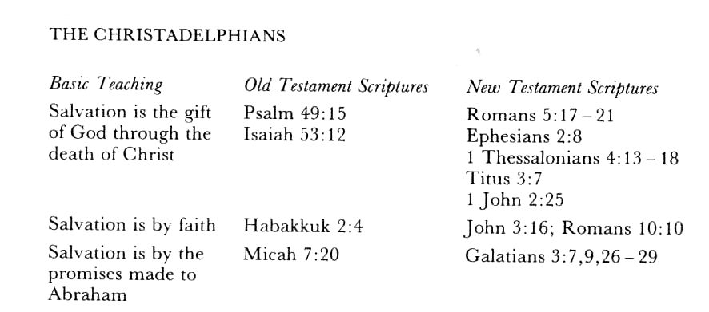
See also the following graphic:
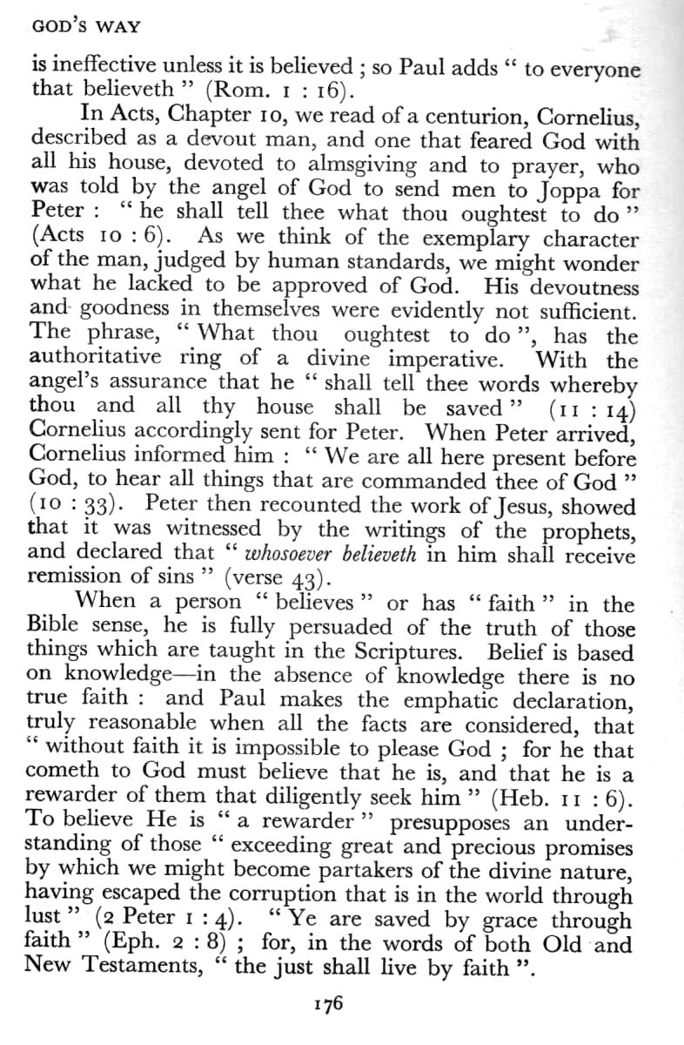

Solution to problem 5:

Hutchinson's insertion of (all men) into the quote from Hebrews 9:27 assumes that everyone is responsible. But if you read your Bible you will find out that this is just not so. See endnote
Hutchinson's assertion in the above point is proved wrong by his second quote since Daniel says "many" of them that sleep shall awake, so clearly NOT "all"!
It is also proved wrong by a proper understanding of his next quote, John 5:28, 29. That is what is so misleading about evangelical doctrine. It is a superficial understanding not borne out by proper Biblical analysis. The Greek word translated graves is mnemeion, which means 'memorial' from mneme meaning 'memory' (Online Bible). Only those who are responsible will Christ remember. How can he give eternal life to those who have not "done good"? (v. 29). And how can he condemn a person to damnation if that person has not "done evil", since a person who does not know the gospel is not said to be evil.
The 'all' are those who hear the voice of the Son of God and are, therefore, responsible to his Judgment. (vs. 24). There is, however, a large segment of humanity that has never heard the words of Jesus and will not come forth in the resurrection. (Isa. 26:14; Jer. 51:57; Psa. 49:19, 20). These are the dead that God remembers "no more". (Psa. 88:5).
'All' is frequently qualified by the context in which it occurs. The following are examples:
1. Luke 2:1 - "All the world should be taxed" referred to the Roman world and not the areas of North, Central and South America.
2. John 10:8 - "All that ever came before me are thieves and robbers", but this did not include John the Baptist and other prophets.
3. Romans 1:7 - "All that be in Rome" referred to the beloved of God - those called to be saints, and not to the populace.
Similarly, in the passage under consideration, the 'all' refers only to those who hear the words of the Son of God and not to pagans, idiots and children.
The above two dot points are quoted from Wrested Scriptures

Russia to control European nations?
John Hutchinson writes the following in WTSWH
"writing of Russia he (Robert Roberts) says: 'She is to vanquish many countries, and hold a protectorate over them, as indicated by the words, "be thou a guard unto them." Those countries include all the nations of the continent.' What European nations does Russia control today? Russia has lost the hold that she held over most of the continental countries!"
The question and exclamatory comment (in ordinary bold font) are Hutchinson's devious attempt to discredit Robert Roberts.
But firstly, notice he must qualify his comment with "most"? So in the second comment he admits that it is partly true today and his question becomes a pedantic focus on the words "European" and "today".
Secondly, note that the quote is incomplete again. We have added the missing bit in blue bold italics. By eliminating the words of Scripture from Ezekiel he is trying to eliminate part of the Scriptural evidence for the statement by Robert Roberts.
Thirdly, and most importantly most readers of Christendom Astray will be able to determine for themselves that the quote is taken completely out of context, as Robert Roberts has quoted about three-quarters of a page of Scripture to back up his statements.
However, the biggest mistake that Hutchinson makes is his clear implication that the prophet Ezekiel was wrong when he recorded the inspired words of God in Ezekiel 38 that Russia would be at the head of the latter-day Northern Confederacy which includes magog, Rosh (Russia), Meshech, Tubal, Gomer and all his bands, the house of Togarmah and all his bands, Persia, Ethiopia and Libya and many people with him.
Notice that Christadelphians did not say that Russia would be in this position of supremacy "today" (i.e. in 2002). The disintegration of the Soviet Union and the formation of the CIS was a necessary prelude to the dramatic rise and inclusion of the Orthodox Church in the big picture of the Russian Federation. The prophetical fact remains that Russia will be the dominant military power from the Urals to the Atlantic, when--in God's purpose--she will lead this Northern Confederacy into Israel in what is Biblically defined as Armageddon.
A person would have to have their head in the sand not to realize that Russia is beginning to dominate Europe. Why is it that in the following picture Putin is in the centre? And who are they opposing?


Economically Russia has huge energy reserves and Europe needs these, as she is energy deficient. This situation has already resulted in a significant improvement in Russia's economy. Precisely how Russia will become the head of this confederacy remains to be seen. But Hutchinson's comments are premature. The Iraqi war of 2003 and the obvious trends are proving Christadelphian understanding right and Hutchinson wrong. Which European nations opposed the war? France, Germany, and Russia--which if you know your Biblical history are mentioned by Ezekiel--were the most vocal. Spain was initially in the coalition, but one terrorist attack was enough to bring a rapid change in policy.

Eastern Rome - Russia

It was not long ago that we could clearly define the subjects of Russia, Europe and the Papacy. However the boundaries are now starting to blur as the whole of Europe comes together:

"Russia and Europe appear to be joining forces to counter the US's increasing global presence by trying to create "Greater Europe" that would consist of the European Union and the Commonwealth of Independent States. Russia has changed the vector of the post-Soviet region's integration process from pro-Moscow to pro-Europe. And having Russia as its most important ally, Europe likely will encourage post-Soviet states to unite and join the group -- in an attempt to create the world's new power centre." (Stratfor 8.5.03)

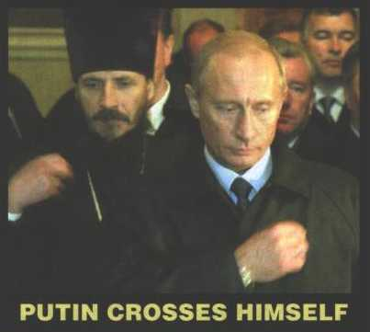 | 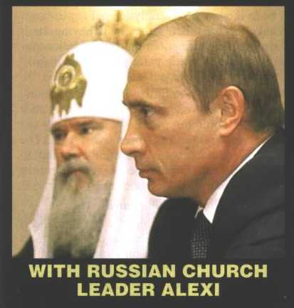

The official EU-Russia website re-enforces this strategy in a 36 page document to the heading "The EU and Russia -- Ever closer Partners in a Wider Europe". The opening section begins:

"Under the terms of the Common Strategy, the EU intends to work together with Russia to meet the following principal objectives: Consolidate democracy; Integrate Russia into a common European economic and social space; Cooperate to strengthen stability and security in Europe and beyond...."

The strategy continues to explain that it aims for "the construction of a united Europe without dividing lines". Similarly a joint statement put out by the Italian Prime Minister Berlusconi, together with European President Mr Prodi and Russia's Mr Putin stated:

"We, the leaders of the European Union and Russian Federation, held intensive and productive discussions in Rome on 6 November 2003. We agreed to reinforce the strategic partnership between the EU and Russia, on the basis of common values, with the aim of consolidating stability, security and prosperity on the European Continent. We reaffirmed our shared vision of a united European continent." (quoted in Milestones 2003 -- D. Pearce, p.68)

"Is this the 'Hope of Israel'?"
Just before this heading appears in WTSWH we have the following:
"The Jews are to be restored to their land. But unlike the Christadelphians, who expect to be immortalized (made omnipotent), and to reign over the world, Jews will have to be content with mortal existence -- but their life span will be extended a few years.
They will be ruled over by immortal Christadelphians and will be their servants. How could a Jew be excited about that even if he should survive the Russian holocaust?
Is this 'The Hope of Israel'?"

There is a confused mixture of partial fact but mostly distortion in this but (in totality) Hutchinson obviously either:
thinks this is what Christadelphians believe, or
he wants his unenlightened readers to think so.
For a person who has had the book Elpis Israel (which means The Hope of Israel) in his possession for as long as he has, ought to know that this in its totality is neither what Christadelphians believe nor is it Bible teaching. So this fact begs the question, "What is John Hutchinson's agenda"?
Mortal Jews Ruled over by the 12 Apostles
We will first of all deal with the emotive part of Hutchinson's comments quoted above.
The mortals during the millennium (defined below) will be ruled over by the saints of all ages, and in particular the mortal Jews will be ruled over by the 12 Apostles, not Christadelphians as Hutchinson alleges.
"And I appoint unto you a kingdom, as my Father hath appointed unto me;
That ye may eat and drink at my table in my kingdom, and sit on thrones judging the twelve tribes of Israel" (Luke 20:29-30).
John Hutchinson needs to reread Elpis Israel instead of deliberately misrepresenting us, for on page 296 of the fourteenth edition this quote from the gospel of Luke is quoted by John Thomas as well as reference made to the one in Matthew 19:28. But please read on.
Mortal during the Millennium
Yes, the Jews who are alive and still in the Diaspora after Armageddon are to be restored to their land. When we use the word Jews in this context it refers to those who do not accept Jesus as their Messiah until he reveals the wounds in his hands and side to them (Zech. 12:10; 13:6). By this time the judgement is over and those who have led a faithful life will have been immortalized. Prior to this, these Jews will not have known the gospel so will not be at the judgement seat. But this fact is no different than the rest of unenlightened humanity who survive Armageddon. They go into the Millennium as mortals. Jesus does not judge a person if they don't know the gospel and conversely he does not reward them with immortality either.
So a proper understanding of the "they" of Hutchinson's second paragraph quoted above is not just Jews who survive Armageddon, it is all of humanity: Jews and Gentiles who were ignorant of the Gospel preached unto Abraham (Gal. 3:8) when Jesus returned as Judge.
Immortalized before the Millennium
As far as those Jews who had the faith of Abraham before the Second Coming or those described by Paul (who was a Jew) in the following quote they are Abraham's seed and if faithful will have been immortalized.
"For as many of you as have been baptized into Christ have put on Christ. There is neither Jew nor Greek, there is neither bond nor free, there is neither male nor female: for ye are all one in Christ Jesus. And if ye be Christ's, then are ye Abraham's seed, and heirs according to the promise" (Gal. 3:27-29).
The "Hope of Israel" then refers to what faithful people believe before the return of Christ and the judgement.
"For this cause therefore have I called for you, to see you, and to speak with you: because that for the hope of Israel I am bound with this chain" (Acts 28:20)
"And now I stand ... for the hope of the promise made of God unto our fathers" (Acts 26:6).
Animal Sacrifices
Hutchinson claims that animal sacrifices will not be a part of the worship of the mortals in the age to come,
"The suggestion that animal sacrifices will be reinstituted is a denial of the gospel..." (WTSWH p. 10).
This unenlightened comment ignores the prophet Ezekiel from chapter 40 to 48 who describes the glorious millennial temple. Who is inspired? Ezekiel or Hutchinson? Perhaps Hutchinson would like to explain what is meant by Ezekiel 44:11, "Yet they shall be ministers in my sanctuary, having charge at the gates of the house, and ministering to the house: they shall slay the burnt offering and the sacrifice for the people, and they shall stand before them to minister unto them"?
This temple and the worship which will occur there are described in The Temple of Ezekiel's Prophecy by Henry Sully in a 110 page large format book published in 1887 in London. See other expositions on this subject at endnote 2.

Other Issues contents
We have included the following topics so that the reader may arrive at a balanced conclusion on them.
C. P. Wachope
Hutchinson spends a whole page on C. P. Wauchope. However, C. P. Wauchope made predictions of his own that did not agree with general Christadelphian understanding. In fact I don't know anyone who shared his views. Many communities have a few radical individual members who sometimes promote their own ideas after the manner of Korah, dathan, and Abiram (Numbers 16). It is uncharitable of Hutchinson not to recognise that fact. The interest of Christadelphians in the report in Hansard was because the second coming of the Lord Jesus Christ was put before the Australian parliament.
"Thomas was a plagiarist"
"Thomas was a plagiarist who stole the writings of others and claimed them as his own original work." WTSWH, page 10.
This unsubstantiated claim suggests that that John Thomas was the same sort of person as Joe Smith. John Hutchinson presents no evidence in his pamphlet nor his website.
However, John Thomas should have put in the words that appeared when Anatolia was reprinted as Exposition of Daniel: “…He does not mean to say, that it contains no quotations; but that as an exposition it is not a mere rehash of the theories of others.” or something similar as it would not have allowed his enemies to trash him like John Bedson and his predecessors such as Hutchinson have done.
As far as Elpis Israel is concerned, John Thomas did indicate the following in the fourth edition (Logos reprint) from which this graphic was captured:
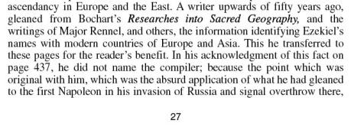
So if the reader looks carefully there are three sources given:
- Bochart’s Researches into Sacred Geography,
- The writings of Major Rennel
- Fredegarius’ History (see page 442 graphic below)
The “writer”—whom we now know to be Granville Penn—was described by John Thomas as a “compiler”, and the reason why “he did not name the compiler” is because of Penn’s “…absurd application of what he had gleaned to the first Napoleon…”
If the reader is aware that the first edition of Elpis Israel was rewritten in the space of 4 months after declaring the original manuscript “as unsuitable” (page XIX 14th edition) it must be agreed that it was a huge task and things would be missed which should have been included in the first edition. The failure to mention this initially may have been the cause mentioned in the following: “In writing Milestones, I am expressing the ideas and discoveries of others in my own words. This happens in every field. Although I try to quote sources where possible, much of what one writes is what one subconsciously absorbs. The sad thing is when one's bitterness warps one's recognition of this fact and use it as the basis of a strong attack” (Refutation of JB in an email from Don Pearce to the author 28 Jan. 2014).
It reminds me of the occasion when my best—now late—friend accused me of being a plagiarist. I thought it was a joke in that I had reproduced his structure of Problem Solution and point form, from Wrested Scriptures in my subsequent book: the Spirit (see graphic below) http://www.christadelphia.org/books/spirit/index.html. It was 20 years later that I discovered that I had copied some notes from his book on 1 Corinthians 9, 11, 13 without giving the source. So this copying may have occurred by Bro. Thomas, without him being aware of it. If there is another printing I plan to include as footnote to say Bro. Ron was the source.
Years ago I had a friend in London, UK compare Elpis Israel to Granville Penn’s writings and he concluded that approximately 7 pages were transferred. However, Penn was a compiler and not the originator of these ideas, the sources of which are specified above.
The page # mentioned in the graphic above is a typo and should read 442 as the following graphic illustrates:
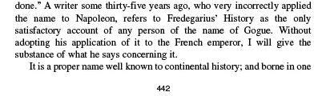
So John Bedson’s claim about Elpis Israel ‘much of "Elpis Israel"… had been taken from other writer's work [sic] but not acknowledged by him.’ amounts to an ad hominem attack, since approx. 7 pages cannot accurately be described as “much”. I agree that what was transferred (approx. 1 % as far as I am aware) should have been in quote marks where this was possible—in that he was giving the “substance”. Possibly another reason why John Thomas did not wish to name Granville Penn was that he was a Trinitarian minister as the following last paragraph from his aforementioned book demonstrates:
‘Wherefore — "O Lord Jesus Christ!… grant that the ministers … of Thy mysteries may likewise so prepare …Thy way, …who livest and reignest with the Father, and the Holy Spirit, ever one God, world without end!"’
Years later the editor, CC Walker, had this to say on the matter:
"...We quite appreciate his reluctance to burden his (i.e. John Thomas') pages with refutations of untenable theories, but it seems to be only right and reasonable to indicate sources so extensively drawn on... "
So what we have is an ad hominem (attacking the person rather than the written matter) attack by Hutchinson upon John Thomas without any attempt to prove wrong this exposition of the identity of the countries mentioned in Ezekiel 38.

As to the claim by JB that “…80% of Eureka had been lifted out of” HA, I have checked each of the 22 chapters of Eureka against Horae Apocalypticae. An 80% “lift” would require out of:
465 pages in volume 1 of Eureka
395 pages in volume 2 of Eureka
376 pages in volume 3 of Eureka
414 pages in volume 4 of Eureka
365 pages in volume 5 of Eureka,

a total [of 2015 * .8 =] 1612 pages to have been copied.

8% would be 161 pages
.8 % would be 16.1
.1 % would be 2.015 pages, which is roughly what I found in my comparison and that is assuming a worst-case scenario. So JB has made an 800 % error in his claim!
In fact, John Thomas was widely read and frequently refers to the writings of others, generally to disagree with them. The reader should not be deceived by such sensational slander.

Roger Stokes
This person belongs to a tiny radical group which numbers less than 10 in the whole world! So Christadelphians put no weight whatsoever in what he says or claims. For John Hutchinson to assume that Stokes speaks for the Christadelphian community shows how little he understands us or how desperate he is to discredit us and how unbalanced is WTSWH.
"Saints (immortalized Christadelphians)"
'The saints (immortalized Christadelphians), will be associated with the Lord Jesus in destroying the political, ecclesiastical, and social systems. This is a work of devastation. It will involve much destruction of life -- bloody and scathing the judgements ministered at the hands of Jesus and the saints'. (p.223)
Again Hutchinson makes a false and misleading quotation from Christendom Astray. The words "immortalised Christadelphians" have been added by Hutchinson, possibly deliberately to deceive his readers. It is NOT part of the quotation. Since Hutchinson quotes from various Christadelphian writings he must know that the Bible phrase "the saints" is understood by Brethren in Christ to mean all those who have served God faithfully and in truth down throughout the ages, starting from the first man Adam.
It is also misleading since Hutchinson omits many words (highlighted below by bold italics) from his quote including substantiating Scripture, thus implying that this is merely Robert Robert's opinion. It would be best for the reader to read for themselves all of Lecture 15, "Coming Troubles and the Second Advent".
http://www.antipas.org/books/chris_astray/ca_lec15.html viewed 6/2/2015
But for those who don't have access to this we will supply some of the context.
'The saints co-operate with Christ in executing the judgments written. This honour is in reserve for them all. It will be their privilege "to execute vengeance upon the heathen, and punishments upon the people; to bind their kings with chains, and their nobles with fetters of iron; to execute upon them the judgment written: this honour have ALL HIS SAINTS" (Psalm 149: 7-9). This "honour" will be sustained at the time contemplated in the words of Daniel, chap. 7: 22: "JUDGEMENT was given to the saints of the Most High; and the time came that the saints possessed the kingdom." Paul reminds the Corinthians of this approaching elevation of the saints to the judgment-seat: "Do ye not know that the saints shall judge the world? and if the world shall be judged by you, are ye unworthy to judge the smallest matters? Know ye not that we shall judge angels? How much more things that pertain to this life"? (1 Cor. 6: 2, 3). It is also seen by John in vision, as recorded in Rev. 20: 4: "I saw thrones, and they sat upon them, and judgment was given unto them."
Thus it is obvious that in the closing judgment-scenes of this dispensation, the saints will be associated with the Lord Jesus in destroying the political, ecclesiastical, and social systems which aggregately constitute "this present evil world." This is a work of devastation for which the mere religious sentimentalists of the age would be unfit. It will involve much destruction of life, after the wholesale example of the flood, and develop a time of trouble, such as never has been witnessed since there was a nation on earth- "a day of darkness and gloominess-a day of clouds and thick darkness-the great and dreadful day of the Lord." Widespread will be the desolations produced; bloody and scathing the judgments ministered at the hands of Jesus and the saints. "The lofty looks of man shall be humbled; and the haughtiness of men shall be bowed down, and the Lord alone shall be exalted in that day; for the day of the Lord of Hosts shall be upon every one that is proud and lofty, and upon every one that is lifted up, and he shall be brought low.... They shall go into the holes of the rocks, and into the caves of the earth, for fear of the Lord, and for the glory of his majesty, when he ariseth to shake terribly the earth" (Isa. 2: 11, 12, 19).'
The reader should note however that before these two paragraphs many Bible passages are referred to or quoted which prove this devastation. E.g. "The Lord at thy right hand shall strike through kings in the day of his wrath. He shall judge among the heathen; he shall fill the places with dead bodies. He shall wound the heads over many countries" (Psa. 110: 5,6).
"False Prophets -- a sign of the times!

Those who have predicted so consistently and falsely may themselves be a fulfilment of prophecy. For Jesus said: 'For false Christs and false prophets will arise and show great signs and wonders, so as to deceive, if possible, even the elect . . . Therefore if they say to you, "Look, He is in the desert!" do not go out; or "Look, He is in the inner rooms!" do not believe it.' (Mat. 24:26-27)"
We really need to feel sorry for John Hutchinson as he can't seem to get his quotes nor his contexts right. He does not quote from verse 27 at all and the first part before the dots is from verse 24. Also he has obviously missed the context of what he quotes so completely that he does not even realize that it refers to AD70 and the destruction of Jerusalem by the Romans! E.g. "Then let them which be in Judea flee into the mountains" (v. 16). Besides no Christadelphian claims to be Christ or a prophet, nor do we show great signs or wonders. So clearly his conclusion is invalid also because the prophecy he quotes has nothing to do with Christadelphians.

"Thomas postulates 2 Gogs and Magogs!"
After quoting from three parts of John Thomas' writings, the above title appears in WTSWH but nothing about that follows the title. Again it is a bit of sloppy writing by John Hutchinson who you may recall is trying to point the finger at someone else. But it is not John Thomas who postulates this as Hutchinson exclaims. In fact it is the subject of two of God's inspired prophets. For the sake of getting the facts before the reader we quote from Elpis Israel:-
'These names occur together in two remarkable prophecies, the one delivered through Ezekiel, (Ezek. 38:2-3; 39:6) and the other through the apostle John (Rev 20:8). No portion of scripture has been more mangled, perhaps, than these; yet there is none, as it appears to me, more easy to be understood. An illustration of popular opinion on the subject may be seen in Guildhall, or in "the Lord Mayor's Show," where two huge giants appear, whom the wise men of Gotham have rhantized "Gog and Magog!" Interpreters have enlightened the public upon this subject about as much as the wooden giants themselves. They generally confound the Gogue and Magogue of Ezekiel with the Gogue and Magogue of the Apocalypse; but if the reader carefully examines the two testimonies, he will find that they have reference to different times exceedingly remote from each other. The Apocalyptic Gogue and Magogue are the nations and their leader, who rebel against the government of Christ and his saints, 1,000 years after the binding of the Greco-Roman Dragon is finished...
If the reader compares the two prophecies, he will discern the following diversities, which prove them to be confederacies belonging to different epochs.
- The Gogue of Ezekiel invades Judea "in the latter days"; but the Apocalyptic Gogue does not invade the land till 1,000 years after the binding of the dragon;
- Ezekiel's Gogue goes forth from the north; John's from the four corners of the earth;
- The Ezekiel-Gogue's invasion is the occasion of the Lord's manifestation, and therefore pre-millennial; but that of John's Gogue is after the Lord has reigned with his saints on earth 1,000 years, and therefore post-millennial;
- The Lord himself brings the Ezekiel-Gogue against his land; but some arch-rebel stirs up hitherto loyal nations against the government, and as the Apocalyptic Gogue and Magogue defy the king already in Jerusalem;
- The Lord brings the Ezekiel-Gogue up to battle against Jerusalem, that He may be made known to the Nations; but John's Gogue has known Him for 1,000 years..." '
It is fairly obvious that Hutchinson has had decades to learn these facts but he belongs to the Apostasy, which in fact will oppose Christ when he declares himself King, so is it any wonder he cannot understand what is so clear?

Conclusion contents
John Hutchinson's point that date setting should not have occurred is correct, but his misuse of Scripture and his conclusion is not valid, as we demonstrated in our critique.
For reasons best known to himself, John Hutchinson (or perhaps one of his friends) has searched several Christadelphian books and pamphlets looking for errors. However, we have shown that his research has fallen far short of that necessary to produce a balanced and accurate picture of those who call themselves Christadelphians or Brethren In Christ. Therefore, he has made a lot of statements in WTSWH that were fairly easily proved wrong and some that are unbalanced.
It would appear that his understanding of the Scriptures is at best piecemeal and superficial which is typical of evangelicals. If he would have read Elpis Israel and Christendom Astray with his Bible at his side he would have understood the true gospel, what the Hope of Israel is, and also that the Christendom to which he clings is astray from the foundational message of the Bible. Like so many in Christendom, he quotes verses out of context and historical context, and also ignores so many other verses that have a bearing on his interpretation.

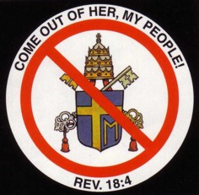
Clearly he is in the position described by the Apostle Paul in Ephesians 2:12 -
"That at that time ye were without Christ, being aliens from the commonwealth of Israel, and strangers from the covenants of promise, having no hope, and without God in the world".
Don't be deceived. Baptists, the group to which Hutchinson belongs, are one of the harlot daughters of the Roman Catholic Apostasy which will think that Jesus Christ is the antichrist and oppose him when he establishes his rule in Zion (i.e. Jerusalem) and demands that all recognize him (Psalm 2).

Acknowledgements contents

I thank our Father and His Son the Lord Jesus for the revelation of the gospel for without that there would be no foundation with which to establish truth.
I would like to thank those in the brotherhood who assisted in the production of this critique. Of particular help were the comments of Paul Cresswell that gave me the encouragement to get on with it. Some of those comments have been incorporated into this document or form the basis of fuller comments.

Endnotes

PO Box 1053, Victor Harbor, South Australia 5211. The edition of WTSWH that we are commenting on is the 2002 edition. In email correspondence John Hutchinson admitted his web site has changed but he did not say what had changed nor why.
For example, The Temple of the Millennial Age and the worship which will occur there are described in The Temple of Ezekiel's Prophecy by Henry Sully in a 110 page large format book published in 1887 in London and for several decades by Logos Publications, Box 220, Findon, SA 5023. The subject is also covered in Eureka and A Handbook to Ezekiel's Temple by D. Beale, published by CSSS, 85 Suffolk Road, Hawthorndene, S. Australia 5158, as well as numerous articles and letters in Christadelphian magazines for over 100 years. See also http://www.google.com.au/imgres?imgurl=http://upload.wikimedia.org/wikipedia/en/d/d3/Henry_Sulley%2527s_rendering_of_Ezekiel%2527s_Temple.jpg&imgrefurl=http://en.wikipedia.org/wiki/Henry_Sulley&h=206&w=280&tbnid=myuct1Mr40m2_M:&zoom=1&docid=KXeJNAKXl340qM&ei=c57TVKW_MYXBmAXS1ILYDA&tbm=isch&ved=0CCAQMygDMAM contents viewed 6/2/2015
For example, Elpis Israel by John Thomas and Christendom Astray by Robert Roberts both available from CSSS. http://www.christadelphia.org/books/elpis.htm viewed 6/2/2015 http://www.thechristadelphians.net/images/CHRISTENDOM_ASTRAY_PDF.pdf viewed 6/2/2015
Wrested Scriptures by Ron Abel, God's Way by John Carter, Christadelphians: What they believe and preach by Harry Tennant, Preparing for Baptism by Jim Luke, Exploring the Bible by David Evans all available from CSSS, The Declaration etc.
Quoted in, Dr. Thomas: His Life and Work, third edition (The Christadelphian, 404 Shaftmoor Lane, Birmingham B28 8SZ), 1980, pages 124-131. From here on we abbreviate this publisher and address to CMPA.
In his fourth edition, John Thomas corrected what he had said in 1849 about the state of the dead after the resurrection. In so doing, he did not "cover up" but writes three paragraphs in the preface stating his reasons.
For example John Thomas in 1849 suggested in Elpis Israel the non-fundamental idea that the angels came from a pre-Adamic creation on earth. By 1869 he declared he no longer held that idea. "To what orb or planet of the universe they are indigenous, is not revealed..." Phanerosis, Logos Edition, page 66.
Statement of The Faith http://www.christadelphia.org/basf.htm viewed 6/2/2015
WTSWH p. 13.
A ploy is "a tactic or maneuver, especially one calculated to deceive or frustrate an opponent"! (Encarta)
We quote part of his example in the second paragraph of the "omit" subsection.
Published by CMPA, 1966.
See endnote 1! One only has to work with a Word processing document that has had numerous mods by several different editors to know how difficult the task is to decipher what was changed and what it is changed to. Why it was changed is usually never included in the final manuscript.
This document is 11 pages long. Herald of the Future Age vol. III, number 4, (Richmond, Va., 1847).
Quoted in, Dr. Thomas: His Life and Work, third edition (CMPA), 1980, pages 124-131.
We are referring here to The Christadelphian or CMPA
It is only partial because we don't have access to other editions.
Hutchinson quotes from the 1849 edition (i.e. first edition) so his implication is that all later editions omit the underlined sentences.
Logos Publications, Box 220, Findon, SA 5023 republished the fourth edition of Elpis Israel in January 2000. Surely if Christadelphians wanted to "cover up" something, this edition would never have been reprinted.
Preface to fourth edition, page xxiii of the 14th edition, CMPA.
It should be pointed out that when Robert Roberts delivered his lectures in 1862 he was only 23 years old, hardly the age that a fair critic would expect he would not make some mistakes.
Elpis Israel, p441, 442, fourteenth edition, CMPA, 1966
"India and Israel have agreed to go in for a new comprehensive agreement for cooperation in science and technology. This will spell out the common agenda, methodology, joint technology development and upgradation of technology. Within six months, the two sides will prepare a Plan of Action, identifying the joint projects to be taken up besides other activities for implementation during the next two years." http://pib.nic.in/release/rel_print_page1.asp?relid=454 viewed 6/2/2015
'JINSA Holds Second U.S.-India-Israel Conference on Counter Terrorism Leading experts from the United States, Israel and India met in Herzliya, Israel, Feb. 16-17, 2004 to forge a consensus on the importance of strategic cooperation in the war on terrorism. The occasion was the second annual trilateral conference on counter terrorism, sponsored by JINSA and several Israeli and Indian partners.' http://www.jinsa.org/articles/articles.html/function/view/categoryid/1723/documentid/2442/history/3,2359,2166,147,1723,2442 viewed 2005
The theme of the return of Christ so dominates the two letters that an appropriate title for the letters is "Waiting for his Son".
In apostate theological vernacular, it is the false doctrine of "the immortality of the soul".
A CSSS Bible insert.
Recommended reading is The Dragon and the Lamb, CSSS 85 Suffolk Road, Hawthorndene, S. Australia 5158. A fuller study is Eureka by John Thomas, CMPA or Apocalypse Epitomized by Logos Publications.
Page 13 of the fifth edition. Available from CSSS.
See How Sure Are The Foundations? - An Appeal to Roman Catholics by Colin Badger, CSSS 85 Suffolk Road, Hawthorndene, S. Australia 5158
See Mormonism - an historical and Scriptural analysis by Forrest Brinkerhoff, 1988 CSSS
See The Spirit - A General Exposition on New Testament Usage by Aleck Crawford, 1990 Logos Publications, Box 220, Findon, SA 5023, or the Web http://www.christadelphia.org/books/spirit/index.html viewed 6/2/2015
See 'Jehovah's Witnesses' -- A Scriptural and Historical Analysis by Ron Cowie, CSSS, 2004
H. Tennant, Vol. 106: The Christadelphian: Volume 106. 2001, c1969. (electronic ed.). Logos Library System (Vol. 106, Page 412). Birmingham: CMPA. [Nine years later he became chairman of CMPA.]
Fred Pearce, Vol. 111: The Christadelphian: Volume 111. 2001, c1974. The Christadelphian, volume 111. (electronic ed.). Logos Library System (Vol. 111, Page 507-508). Birmingham: CMPA.
For example in Clerical Theology Unscriptural, 1850 and in many other writings which demonstrate that Plato's theory of the immortality of the soul is unscriptural. http://www.the-gospel-truth.info/2011/clerical-theology-unscriptural-part-1/ viewed 6/2/2015
Elpis Israel. page 187, 14th Edition 1966 Revised, Birmingham: CMPA.
"THE APOSTACY UNVEILED A DEBATE BETWEEN DR. THOMAS AND A PRESBYTERIAN CLERGYMAN, THIRTY-THREE YEARS AGO, ON THE LEADING DOCTRINES OF CHRISTENDOM IN RELATION TO BIBLE TRUTH ... Why that natural or animal men understood certain of the 'mysterious wisdom of God before Jesus revealed it. But to say this, would be to contradict the Scriptures; for Paul says that the wisdom of God on these topics had been 'hitherto concealed' and that 'life and immortality were brought to light by Jesus Christ in the Gospel.' The doctrine of immortality is a 'spiritual thing' and, therefore, from its very nature was incomprehensible to the world of animal men, until spiritually revealed. 'Now,' says Paul, 'an animal man receives not the things of the Spirit of God; for they are foolishness to him.' This is true; for when the apostle announced the immortality of man by a resurrection from the dead at Athens, the Epicurean and Stoic leaders of the ignorant multitude, mocked him for a babbler. And even now the scriptural teaching on this topic is as incredible and absurd in the estimation of my opponents and the mass as it was to them. I have said that the phrase 'immortal soul' or 'immortality of the soul' is not in the Bible; therefore, I conclude, that the idea or thing is not taught there. But among 'the words taught by the Spirit,' there are immortal, immortality, Spirit, soul, and so forth; hence the ideas or things signified are there too. But soul is one idea, an "immortal soul' quite another; and immortality is one thing, and 'immortality of the soul' another. Soul, immortal, immortality are indeed found in the Bible, but 'immortal soul,' and 'immortality of the soul' are not, but chiefly in the speculations of Plato, and in the systems of scholastic divinity.... It is important, when persons listen to the conversation and discourses of others, that they should, if they would comprehend one another, understand the language or terms used by the speaker..." (Vol. 8: The Christadelphian: Volume 8. 2001, c1871. (electronic ed.). Logos Library System (Vol. 8, Page 204). Birmingham: CMPA).
ibid., page 187 same paragraph.
Parkhurst's Concordance was written in 1762 (Hebrew) and 1769 (Greek), so students in 1850 would have access to this concordance. His comments on nephesh are that it means 'an animal which has breathed', 'living creature or animal', 'animal frame', (page 389 in 1823 edition) and on psuche that it means 'animal life', 'human animal soul', etc. (page 708 in 1825 edition).
A Critical Lexicon and Concordance to the Greek New Testament, E.W. Bullinger. London: Samuel Bagster & Sons 8th edition 1957.
In fact, if John Hutchinson really knew what John Thomas thought of the Mormons he would never have misquoted Elpis Israel in an attempt to support his allegation. In 1849 John Thomas wrote a 24 page exposure on the Mormons while he was in England in 1849. It is entitled Sketch of the rise, progress, and dispersion of the Mormons. In a magazine in 1853 he wrote the following words: "having nothing but utter contempt for Mormonism..."
The following from John Thomas is also relevant. "What we must do to obtain Eternal Life 1. The Scripture not only teaches what the animal man is as a physical and a moral being, but what he may become. It shows that he has "no good thing in him;" that he has no pre-eminence over other animals more than the perfection of his organization confers upon him; and that, therefore, he is destitute of inherent holiness, righteousness, immortality, honour and glory. He is a humbled creature, made subject to vanity and at enmity against God and His laws. 2. These things being abundantly demonstrated both in the works and word of God, the future destiny of man as predicable upon the constitution of his nature, is that of an eternal cessation of his existence, from the time he shall have mingled with his parent dust. This is the conclusion to which revelation and science will conduct every disciple of truth, who is independent of prejudice and party, and who has the courage to confess her in the face of ignorance, bigotry, and persecution." Vol. 7: The Christadelphian: Volume 7. 2001, c1870. (electronic ed.). Logos Library System (Vol. 7, Page 225). Birmingham: CMPA.
Yahweh the Creator: "For thus saith the LORD that created the heavens; God himself that formed the earth and made it; he hath established it, he created it not in vain, he formed it to be inhabited: I am the LORD; and there is none else" (Isa. 45:18). "Before the mountains were brought forth, or ever thou hadst formed the earth and the world, even from everlasting to everlasting, thou art God (El)." (Psa. 90:2) See also 1 Cor. 8:6; Acts 14:15; Psa. 146:6; 115:15; 121:2; 124:8 etc.
Christadelphians say so: Exploring the Bible Third Edition, published by Christadelphian Scripture Study Service 85 Suffolk Road, Hawthorndene, South Australia 5051, 2003 page X, 7, 9, 237 etc. The Christadelphians – what they believe and preach published by CMPA, 1986, pages 1-4, 7, 15, 93 etc
Elpis Israel, "revolving upon is own axis...is a planet (i.e. earth) ... [which] declares the glory of God ... that did create it." Page 1. "Now, as the scripture saith, the Great Builder of the heavens and earth is God" (p.169 Fourteenth edition) etc.
It is clear to any who wish to investigate the matter that in the passage that Hutchinson misquotes, John Thomas is talking about the Elohim. The subtitle of the section on page 181 is "Dissertation on the Elohim". So he is not writing about Platonism nor Mormonism. He is zeroing in on the Hebrew text and in particular Genesis 1:1 so as to explain verse 26 ("Elohim said, 'Let us make man in our image'") properly.
See also Isaiah 43:10 "...before me there was no God (Heb. El) formed, neither shall there be after me."
A check of a Bible Concordance such as Strong's will show that the word translated God in Genesis 1:26 is the Hebrew word Elohim.
See God's Way by John Carter, second edition CMPA, 1963, pages 31 & 32 for an extended explanation of this form of language sometimes described as "God manifestation".
See Hebrews 13:1 where it is also obvious that Abraham "entertained angels unawares".
Again, we notice that salvation is not a present possession. If you are an heir of something, you don't yet have it.
This is Philip Yancey's false gospel. See A Review of Philip Yancey's book entitled "What's So Amazing About Grace?" by Andrew Dangerfield and Jonathan Burke published by CSSS.
The above quotes are just a few. Many others say the same thing. See also Acts 14:22; Rom. 11:22; Matt. 24:13; 2 Pet. 2:20; Heb. 3:6, 14 etc.
WTSWH, page 8
http://www.wrestedscriptures.com/b04resurrection/1corinthians15v52.html viewed 6/2/2015
The question as to which single characteristic saves the man is an abstraction. An illustration is helpful. A man who has fallen into the river screams for help. A man on the bank runs with a rope and throws it to the man in the river. He catches hold and is pulled to safety. What saved him? Was it his scream? Was it the rope? Was it the man on the bank? Did he save himself? Or was it all of these working together?
This dot point is quoted from http://www.wrestedscriptures.com/webring.htm viewed 6/2/2015
Graphic from The Christadelphians what they believe and preach, Harry Tennant, p. 252, CMPA, 1986
Graphic from God's Way by John Carter CMPA 1963.
If man has an 'immortal soul' naturally, he is forced to have an eternal destiny somewhere - either in a place of reward or of punishment. This implies that everyone is responsible to God. By contrast, we have shown how the Bible teaches that by nature man is like the animals, without any inherent immortality. However, some men have been offered the prospect of eternal life in God's Kingdom. It should be apparent that not everyone who has ever lived will be resurrected; like the animals, man lives and dies, to decompose into dust. Yet because there will be a judgment, with some being condemned and others rewarded with eternal life, we have to conclude that there will be a certain category amongst mankind who will be resurrected in order to be judged and rewarded. Whether or not someone will be resurrected depends on whether they are responsible to the judgment. The basis of our judgment will be how we have responded to our knowledge of God's word. Christ explained: "He that rejecteth me, and receiveth not my words, hath one that judgeth him: the word that I have spoken, the same shall judge him in the last day" (John 12:48). Those who have not known or understood the word of Christ, and therefore had no opportunity to accept or reject him, will not be accountable to the judgment. "As many as have sinned without (knowing God's) law, shall also perish without law: and as many as have sinned in the law (i.e. knowing it), shall be judged by the law" (Rom. 2:12). Thus those who have not known God's requirements will perish like the animals; whilst those who knowingly break God's law need to be judged, and therefore resurrected to face that judgment. In God's sight "sin is not imputed when there is no law"; "sin is the transgression of the (God's) law"; "by the law is the knowledge of sin" (Rom. 5:13; 1 John 3:4; Rom. 3:20). Without being aware of God's laws as revealed in His Word, "sin is not imputed" to a person, and therefore they will not be judged or resurrected. Those who do not know God's Word will therefore remain dead, as will animals and plants, seeing they are in the same position. "Man that...understandeth not, is like the beasts that perish" (Ps. 49:20). "Like sheep they are laid in the grave" (Ps. 49:14). It is having the knowledge of God's ways that makes us responsible to Him for our actions and therefore necessitates our resurrection and appearance at the judgment seat. It should therefore be understood that it is not only the righteous or those baptized who will be resurrected, but all who are responsible to God by reason of their knowledge of Him. This is an oft repeated Scriptural theme:- John 15:22 shows that knowledge of the Word brings responsibility: "If I (Jesus) had not come and spoken unto them, they had not had sin: but now they have no cloke ('excuse', A.V. mg.) for their sin". Romans 1:20-21 likewise says that knowing God leaves men "without excuse". "Every man therefore that hath heard, and hath learned of the Father...I (Christ) will raise him up at the last day" (John 6:44,45). God only "winks at" the actions of those who are genuinely ignorant of His ways. Those who know His ways, He watches and expects a response (Acts 17:30). "That servant, which knew his lord's will, and prepared not himself, neither did according to his will, shall be beaten with many stripes. But he that knew not, and did commit things worthy of stripes, shall be beaten with few stripes (e.g. by remaining dead). For unto whomsoever much is given, of him shall be much required: and to whom men have committed much, of him they will ask the more" (Luke 12:47,48) - so how much more God? "Therefore to him that knoweth to do good, and doeth it not, to him it is sin" (James 4:17). Israel's special responsibility to God was on account of His revelations to them concerning Himself (Amos 3:2). Because of this doctrine of responsibility, "it had been better for them (who later turn back from God) not to have known the way of righteousness, than, after they have known it, to turn from the holy commandment delivered unto them" (2 Pet. 2:21). Other relevant passages include: John 9:41; 3:19; 1 Tim. 1:13; Hos. 4:14; Deut. 1:39. Knowledge of God making us responsible to the judgment seat, it follows that those without this knowledge will not be resurrected, seeing that they do not need to be judged, and that their lack of knowledge makes them "like the beasts that perish" (Ps. 49:20). There are ample indications that not all who have ever lived will be resurrected: The people of the ancient nation of Babylon "shall not rise" after their death because they were ignorant of the true God (Jer. 51:39; Is. 43:17). Isaiah encouraged himself: "O Lord our (Israel's) God, other lords beside thee have had dominion over us (e.g. the Philistines and Babylonians)...They are dead, they shall not live (again); they are deceased, they shall not rise...all their memory to perish". (Is. 26: .13,14). Note the triple emphasis here on their not being resurrected: "Shall not live (again)...shall not rise...all their memory to perish". By contrast, Israel had the prospect of resurrection on account of their knowledge of the true God: "Thy (Israel's) dead men shall live, together with my dead body shall they arise" (Is. 26:19). Speaking about God's people Israel, we are told that at Christ's return, "many of them that sleep in the dust of the earth shall awake, some to everlasting life, and some to shame and everlasting contempt" (Dan. 12:2). Thus "many", but not all, of the Jews will be resurrected, due to their responsibility to God as His chosen people. Those of them who are totally ignorant of their true God "shall fall, and never rise up again", seeing they are unable to find "the word of the Lord" (Amos 8:12,14). We have now learnt that: 1. Knowledge of God's Word brings responsibility to Him. 2. Only the responsible will be resurrected and judged. 3. Those who do not know the true God will therefore remain dead like the animals. The implications of these conclusions make a hard hit on human pride and what we would naturally prefer to believe: the millions of people, both now and throughout history, who have been ignorant of the true Gospel; the severely mentally ill, who are unable to comprehend the Bible's message; babies and young children who have died before being old enough to appreciate the Gospel; all of these groups fall within the category of those who not have had the true knowledge of God, and are not therefore responsible to Him. This means that they will not be resurrected, regardless of their parents' spiritual status. This runs completely against the grain of humanism and all our natural desires and feelings; yet a true humility to God's Word of ultimate truth, coupled with a suitably humble opinion of our own nature, will lead us to accept the truth of this. A candid examination of the facts of human experience, even without the guidance of Scripture, will also lead to the conclusion that there can be no hope of future life for the groups mentioned above. Our questioning of God's ways in these matters is grossly out of order: "O man, who art thou that disputest with God?" (Rom. 9:20 A.V. mg.). We may admit incomprehension, but never must we accuse God of injustice or unrighteousness. The implication that God can be in any way unloving or in error opens up the horrific prospect of an all-powerful God, Father and Creator who treats His creatures in an unreasonable and unjust way. The record of king David's loss of his baby is helpful reading; 2 Sam. 12:15-24 records how David prayed hard for the child while it was alive, but he realistically accepted the finality of its death: "While the child was yet alive, I fasted and wept: for I said, Who can tell whether God will be gracious to me, that the child may live? But now he is dead, wherefore should I fast? Can I bring him back again?...he shall not return to me". David then comforted his wife, and had another child as soon as possible. The above is quoted from http://www.christadelphians.com/biblebasics/0408responsibilitytogod.html viewed 6/2/2015
Available online at http://www.wrestedscriptures.com/b04resurrection/john5v28-29.html viewed 6/2/2015
Graphic from Milestones 2003 cover, CSSS, January 2004
When viewed in mid 2004. The following words were included in my draft which unfortunately Web Page crawlers found on my ISP Web space and made available in the public domain so that John Hutchinson found it before I finalized it and moved it out of draft mode: "If his claim were true, then Christadelphians and their earlier unfriendly critics would have found this out when it occurred as they would have been much more familiar with books published then, and therefore long before Hutchinson.…" I only mention the above point because Hutchinson tries to prove that we cover up past published mistakes.
In the 14th edition it is on page 429.
CCW, Vol. 63: The Christadelphian: Volume 63, c1926, Page 487.
This error in logic is a familiar ploy used by those who cannot answer the argument presented.
Elpis Israel 14th edition page 421, CMPA
Rev. 17:5.
See Man of Sin by Ron Abel, CSSS.

